**User manual for Object Picking Robot**

**□ Charging the Robot:**

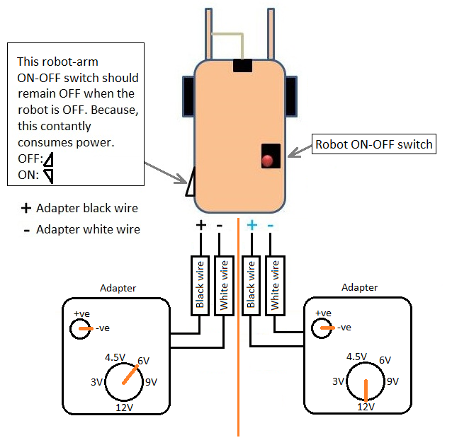

**□ Connecting bluetooh device:**

1. Turn **ON** the Robot.
2. Connect your **Bluetooth dongle** to your computer’s USB port.
3. Select **Bluetooth Devices >> Add a device** from your taskbar.

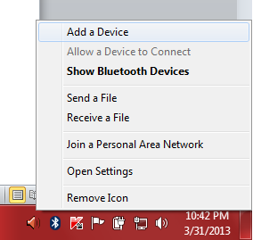

1. Select **Tinyos** and click **Next**.

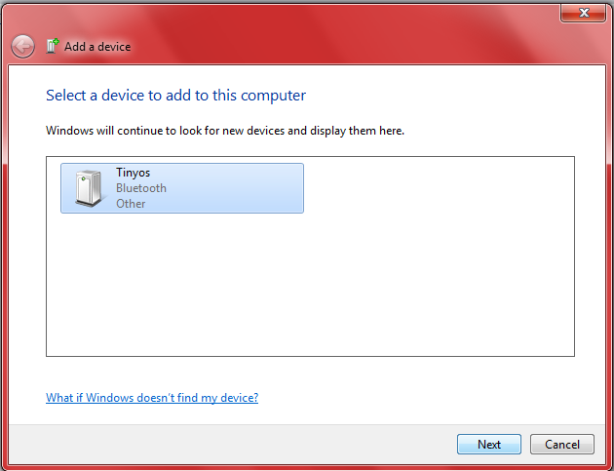

1. Select **Pair without using a code**.

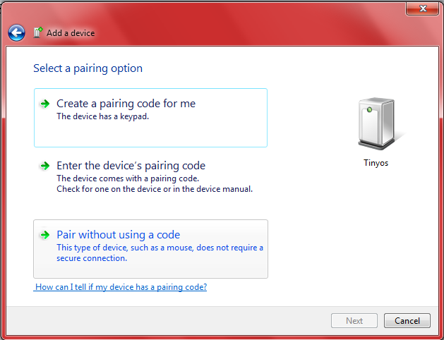

1. The Bluetooth device will be added successfully. Click **Close**.

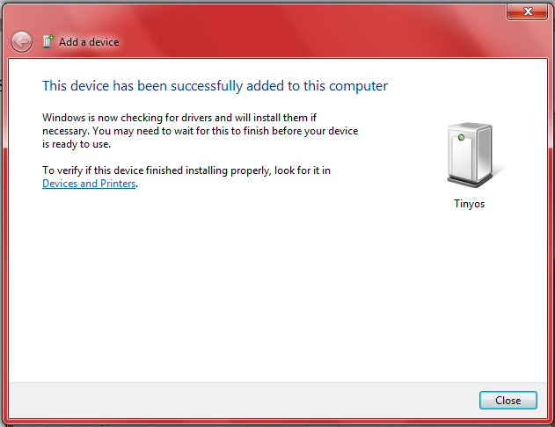

**□ Serial port checking & configuring:**

1. Select **Bluetooth Devices >> Open Settings** from your taskbar.

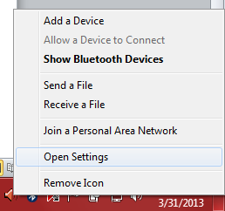

1. There will be 2 COM ports: **Outgoing** & **Incoming**. We need only **Outgoing port**, which is here **COM17**.

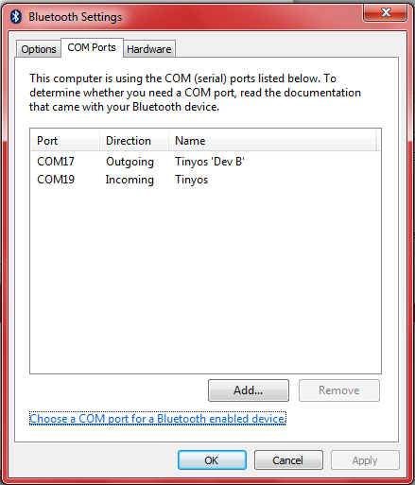

1. Open **Robot >> src >> robot >> comm.txt** and write outgoing port **COM\*\*** there without any new line character. For here, outgoing port is **COM17**.

**□ Installing RxTx before running the Program:**

1. Copy both **rxtxSerial.dll** and **rxtxParallell.dll** to:

**C:\Program Files\Java\jdk1.6.0_03\jre\bin**

**C:\Program Files\Java\jre1.6.0_03\bin**

1. Copy **RXTXcomm.jar** to:

**C:\Program Files\Java\jdk1.6.0_03\jre\lib\ext**

**C:\Program Files\Java\jre1.6.0_03\lib\ext**

**□ Program running:**

1. Turn **ON** the Robot.
2. Copy "**Object picking robot**" folder to "**F:**" drive.
3. Open "**Robot**" project in **NetBeans**.
4. Click "**Clean and Build Project**", then "**Run Project**".
5. Click on the **Bluetooth Devices notification icon** on taskbar.

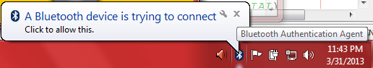

1. Type **1234** as pairing code and Click **Next**.

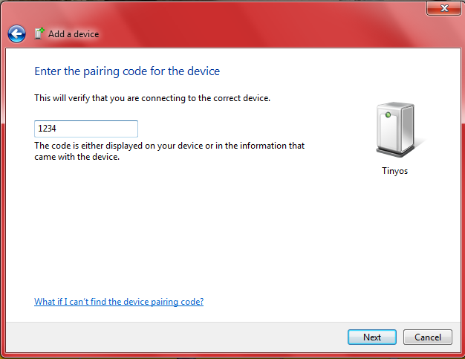

1. Click **Close**.

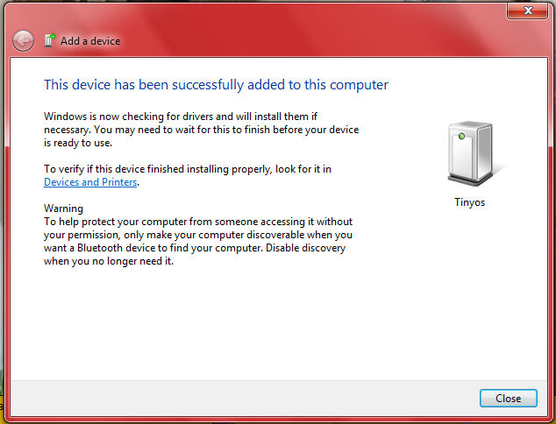

**□ Program commands & operations:**

Move right

Shortcut key:

right arrow

Move forward

Shortcut key:

up arrow

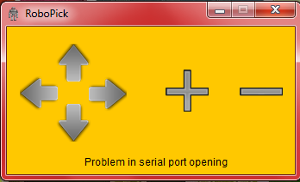

Move left

Shortcut key:

left arrow

Move backward

Shortcut key:

down arrow

Compress hand

Shortcut key: c

Expand hand

Shortcut key: x

**□ Bluetooth Webcam running:**

1. Start **SmartCam** on your computer. Then minimize it to the taskbar.
2. Start **SmartCam** on your Android mobile.
3. Goto **Settings>>Bluetooth server** and then select your desired bluetooth server.
4. Select **Connect bluetooth**.
5. Type **1234** as device’s required PIN and select **OK**.
6. Now, on your computer, click on the **Bluetooth Devices notification icon** on taskbar.

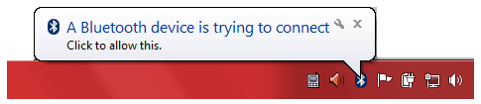

1. Type **1234** as device pairing code and select **Next**.

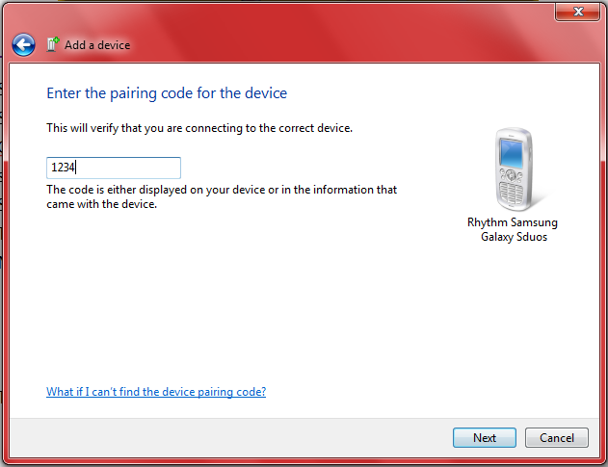

1. The device will be successfully added. Click on **Close**.

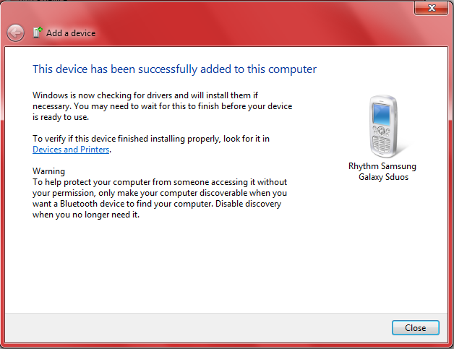

1. Finally, double click on the **SmartCam** icon on taskbar to maximize it. You’ll be able to see the video.

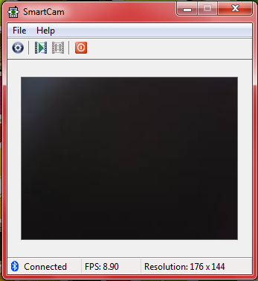

**Done !**